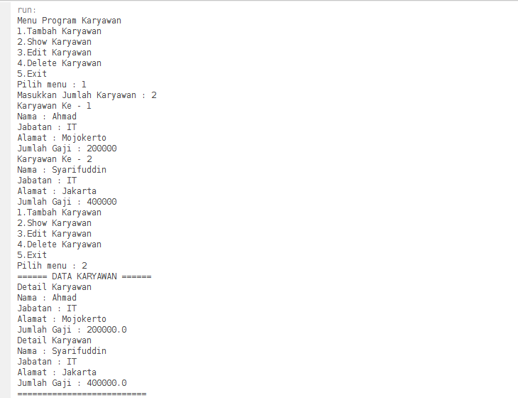

Keterangan Source Code :

-------------------------------------------------------------------------------------------------------------------------------------------------------------------------------------------------------------------------------------------------------------------------------------------------------------------------------------------------------------------------------------------------------------------------------------------------------------------------------------------------------------------------------------------------------------------------------------------------------------------------------------------------------------------------------------------------------------------------------------------------------------------------------------------------------------------------------------------------------------------------------------------------------------------------------------------------------------------------------------------------------------------------------------------------------------------------------------------------------------------------------------------------------------------------------------------------------------------------------------------------------------------------------------------------------------------------------------------------------------------------------------------------------------------------------------------------------------------------------------------------------------------------------------------------------------------------------------------------------------------------------------------------------------------------------------------------------------------------------------------------------------------------------------------------------------------------------------------------------------------------------------------------------------------------------------------------------------------------------------------------------------------------------------------------------------------------------------------------------------------------------------------------------------------------------------------------------------------------------------------------------------------------------------------------------------------------------------------------------------------------------------------------------------------------------------------------------------------------------------------------------------------------------------------------------------------------------------------------------------------------------------------------------------------------------------------------------------------------------------------------------------------------------------------------------------------------------------------------------------------------------------------------------------------------------------------------------------------------------------------------------------------------------------------------------------------------------------------------------------------------------------------------------------------------------------------------------------------------------------------------------------------------------------------------------------------------------------------------------------------------------------------------------------------------------------------------------------------------------------------------------------------------------------------------------------------------------------------------------------------------------------------------------------------------------------------------------------------------------------------------------------------------------------------------------------------------------------------------------------------------------------------------------------------------------------------------------------------------------------------------------------------------------------------------------------------------